  ***GALGOTIAS UNIVERSITY***

Plot No.2, Sector -17 A, Yamuna Expressway,

Greater Noida, Gautam Buddha Nagar, U.P., India

SCHOOL OF COMPUTING SCIENCE & ENGINEERING

CAT-3 Case Study Report File Submission

Year : first Semester : 1

Session : 2021-2022

Submitted By:

ABHINAV KUMAR CHOUDHARY(21SCSE1011615)

Submitted to:

Mrs. ARCHNA Mam

Q1: Plot ellipse. X^2/a^2+Y^2/b^2=1. Take a=4,b=3

Algorithm :

1. Start the program.

(With clc and clear)

2. Now declare the axis of the ellipse.

(major and minor axis)

3. Now display the plot.

4. Declare the titles of the axis.

Program:

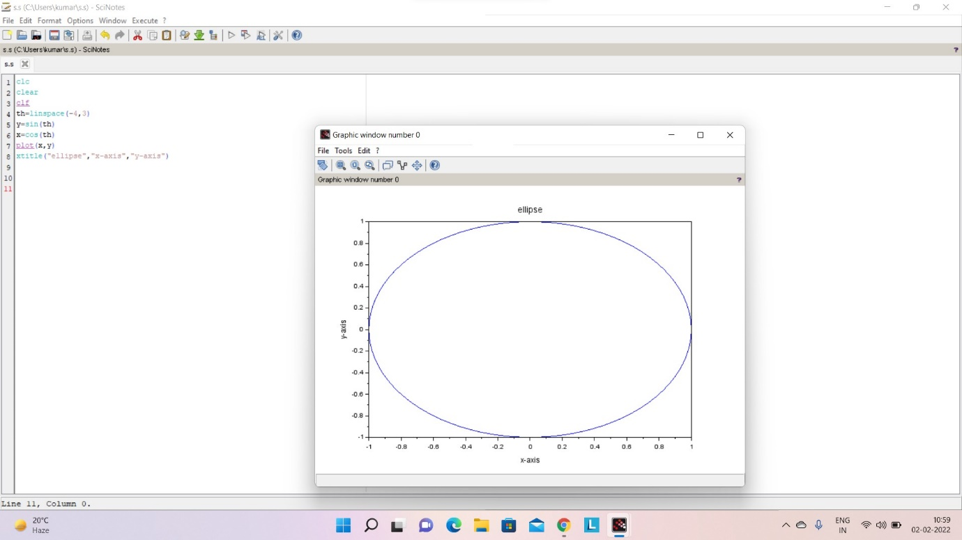

Q2: Plot Sphere X^2 +Y^2+Z^2=a^2,Take a=1

ALGORITHM:

1. Start the program

(with clc and clear)

2. Now first we have to declare linspace for positioning of the sphere.

3. Now declare the radius for sphere.

4. Declare the axis

5. Put colors in sphere

6. and then display on graphics

7. End of the program

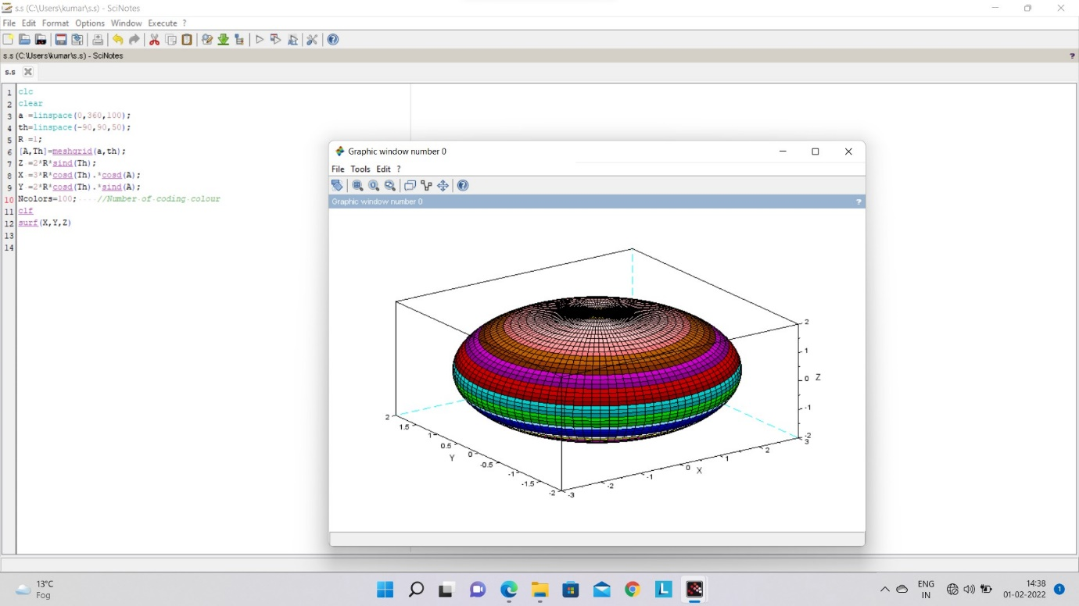

Thank you